BI Protocol
Between Host and Tester

Rev 0.1
9/5/2016

PROPRIETARY AND CONFIDENTIAL

The information contained in this Product Specification is of a privileged and confidential nature and is intended only for use by the intended recipient. You acknowledge and understand that the unauthorized use, disclosure or duplication of any confidential information would cause harm for which legal damages would be inadequate. As such, you understand and acknowledge that reserves its rights to utilize any equitable remedies available to protect its interests in such information in addition to any legal damages it may seek against any unauthorized use of this information.
Revision History

Revision | Version | Date | Description | Initials
0.1 | A | 09/05/2016 | Initial draft | Jianqaing Li &Mingwei Wu

Table of Contents
1 Introduction 4
1.1 Overview 4
1.2 Scope 4
1.3 Reference 4
2 System Requirement 5
2.1 Support eMMC based NANDrive 5
2.2 Support Micron 64Gb 25nm NAND (L74A) 5
2.3 Support cycling 5
2.4 Support retention 5
3 System Design 6
3.1 System Module 6
3.2 Host Module 6
3.2.1 Adapter Module 6
3.2.2 None Data Command 6
3.2.3 Read Command 7
3.2.4 Write Command 7
4 System Implement 8
4.1 Send/Receive Flow 8
4.2 System Running 9

Tables
Table 2-1: Send Receive CMD 5
Table 2-2: Update the header 5
Table 2-3: Support cycling 5
Table 2-4: Support retention 5

Figures
Figure 3-1: System Module 6
Figure 3-2: Host Module 6
Figure 3-3: Adapter Module 6
Figure 3-4: None Data 6
Figure 3-5: Read Command 7
Figure 3-6: Write Command 7
Figure 4-1: Send/Reciv Flow 8

Introduction

Overview
This Protocol spec will describe how to communicate the host and tester.
The protocol field as below:
typedef struct tagBIProtocol
{
uint8_t cmd; //cmd type, 0:get info, 2: power up, 3: power down, 4: set the tester ambient temperature,
uint8_t port; //0~7 indicates the SSD in this tester, 8 indicates all SSDs in this, 9 indicates the tester itself.
uint8_t data[140]; //if cmd is write type, then this byte field is the write value. For example, is cmd = 4, the “data” is the temperature to set.
uint8_t reserved[8];
}BIProtocol;

The request and response should be pair with the same format to reduce the complex and make sure the data consistent
The payload is the fixed size 150 bytes.
The data[140] should contain below trace items.
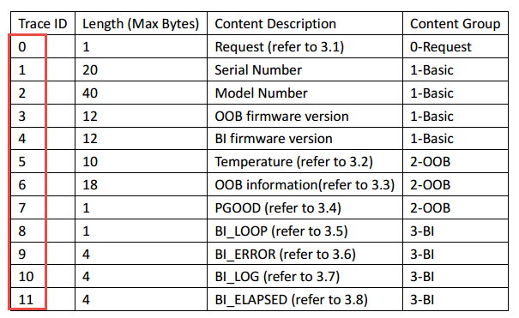

The port 0~7 response as below:
Byte | Length (byte) | Name | Description
0 | 1 | cmd type | Indicates the cmd type, 0: get info, 1: power up; 2: power down and so on
1 | 1 | cmd error code | 0: this cmd is executed successfully, others: error code for failure
2 | 1 | SSD Number | The ssd number in this tester, value: 0~7
3 | 1 | Present | 0: this ssd is NOT present (then the GUI can display yellow, i.e.)  1: this ssd is present and runs normally (GUI display green)  2: this ssd is present but runs with error (GUI display red)
4~5 | 2 | 12V Current value | Uint： mA
6~7 | 2 | 12V Voltage value | Uint： mV
8~9 | 2 | 3.3V Current value | Uint： mA
10~11 | 2 | 3.3V Voltage value | Uint： mV
12~13 | 2 | AUX3.3V Current value | Uint： mA
14~15 | 2 | AUX3.3V Voltage value | Uint： mV
16~35 | 20 | Serial number | Refer to “BI Monitor Interface Specification For PBlaze5 Product”
36~75 | 40 | Model Number
76~87 | 12 | OOB Firmware version
88~99 | 12 | BI firmware version
100~109 | 10 | temperature
110~127 | 18 | OOB Information
128 | 1 | PGOOD
129 | 1 | BI_LOOP
130~133 | 4 | BI_ERROR
134~137 | 4 | BI_LOG
138~141 | 4 | BI_ELAPSED
142~149 | 8 | reserved
The port 8 response should be multiple 8 above responses.
The port 9 response as below:
Byte | Length (byte) | Name | Description
0 | 1 | cmd type | Indicates the cmd type, 0: get info, 1: power up; 2: power down and so on
1 | 1 | cmd error code | 0: this cmd is executed successfully, others: error code for failure
2 | 1 | SSD Number | 9
3~4 | 2 | Average ambient temperature | Uint degC. Byte 3 is the integer part, and byte 4 is the decimal part.
5~6 | 2 | max ambient temperature | Uint degC. Byte 3 is the integer part, and byte 4 is the decimal part.
7 | 1 | max ambient temperature location | The location where the ambient temperature is the highest.
8~9 | 2 | min ambient temperature | Uint degC. Byte 3 is the integer part, and byte 4 is the decimal part.
10 | 1 | min ambient temperature location | The location where the ambient temperature is the lowest.
11~12 | 2 | 12V Current value | Uint： mA
13~14 | 2 | 12V Voltage value | Uint： mV
15~16 | 2 | 3.3V Current value | Uint： mA
17~18 | 2 | 3.3V Voltage value | Uint： mV
19~20 | 2 | AUX3.3V Current value | Uint： mA
21~22 | 2 | AUX3.3V Voltage value | Uint： mV
23~29 | 7 | reserved
The control and special cmd response as below :

Byte | Length (byte) | Name | Description
0 | 1 | cmd type | Indicates the cmd type, 0: get info, 1: power up; 2: power down and so on
1 | 1 | cmd error code | 0: this cmd is executed successfully, others: error code for failure
2~9 | 8 | reserved

Scope
This document is only used for production BI project. The UDP port is 5000.

Reference

Name | Location
04_PBlaze5_Manufacturing_BI_Monitor_Interface_Specification_V0.3 | 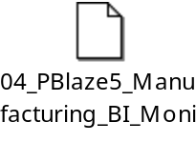

System Requirement

Support Basic Read Data

Function | Interface | Note
Send CMD to Tester | Socket | Block communication
Receive Data from Tester | Socket | Block communication
Table 2-1: Basic Read Data

Support power up and power down

Function | Interface | Note
Power up | Socket | Sent the control CMD
Power down | Socket | Sent the control CMD
Table 2-2: Power up and Power down

Support Set temperature ambient

Function | Interface | Note
Set Temp Ambient | Socket | Sent the special CMD
Table 2-3: Set temperature ambient

System Design

System Module

Host Client
At PC

Test Server at MCU embeded
Socket

Device
SMBus
Figure 3-1: System Module

Host Module
Window OS
Utility
BI CMD
Start
Send
Receive
Stop
WinSocket
Figure 3-2: Host Module

Tester Module
MCU embeded
SMBus driver
Socket
PortOpen
PortSend
PortRecv
PortSet
Figure 3-3: Adapter Module

Control Data Command

Host Send
Command and get result from Tester

Tester executes control command

Socket
Device parses and executes command

Memory
TCP
Bus
Figure 3-4: Control Data

Read Data Command

Host Send
Command and get result from Tester

Tester executes read command

Socket
Device parses and executes command

Memory
TCP
Bus
Figure 3-5: Read Command

Write data Command

Host Send
Command and get result from Tester

Tester executes write command

Socket
Device parses and executes command

Memrory
TCP
Bus
Figure 3-6: Write Command

System Implement

Send/Receive Flow
Socket Init
CMD Init
Send CMD to Tester and wait for response
Check Control data?
Execute Special function
Read Data to Tester
N
Y
Parse the CMD and Send necessary data to device
Figure 4-7: Send/Reciv Flow

System Running

